Anon Society

The history of the founding of ANON.

Introduction

You know that ANON's area of interest is the animal kingdom but our website does not explain what was the source of inspiration for our creator. We asked her to reveal the secret.

Description

Edith (Edyta) is an animal lover, although, for most of her life our TCoA could not fill the "hole in her heart" after losing a four-legged friend in her childhood. In the end, however, she found it in her heart to adopt two cute kittens! Bruce & Lemon (in this exact order).

Bruce lived on the street. On the day of adoption he was a three-month-old male kitten with a very interesting color and a characteristic spot on the front paw. Neglected, he required immediate veterinary care. He suffered from cat flu, scabies and fleas. However, he fully recovered very quickly and today he is a happy, very cuddly individual :)

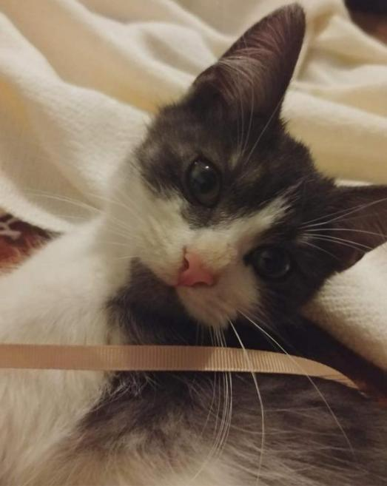

Bruce

Lemon went to Edith (Edyta) as a five-week-old baby kitten. He was given by a family that was not prepared for his presence. At first he was very wild and scared. It took him a long time to get used to his new place and his older brother. In the end he did and today he does not part with Edith (Edyta) and Bruce. Besides, he is extremely lively! He loves to eat flowers, climb up his mum and look for snacks hidden in various corners of their house.

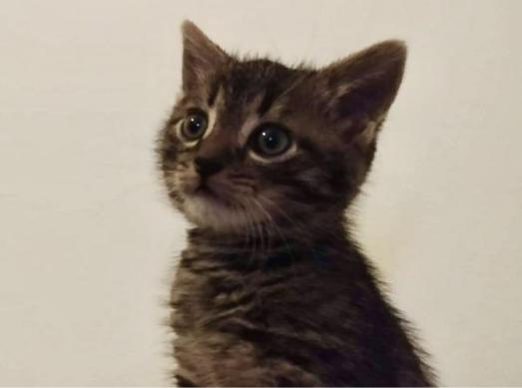

Lemon

Were Bruce & Lemon the source of inspiration for founding ANON? Yes Yes Yes! Living with animals allows us understand that they are actually very similar to us. Especially those that are closely related to us - e.g. chimpanzees, but not only. This is confirmed by current scientific reports and it is worth spreading this knowledge among those who do not believe it.

The magazine *Current Biology* has published results of a study conducted at Oregon State University. It concerned the relationship between an owner and a cat. 70 kittens up to 20 weeks of age and 38 adult cats aged 1 to 13.5 years took part in it. Some of the animals were assigned to the control group and some to the research group. The task was to make the cats stay in a place not familiar for them with a human companion that they know and then without him (for 2 minutes). It was observed that over 65% of the cats expressed affection. Some of them were meowing and did not want to explore the room clearly waiting for their guardian's return. The conclusion was that cats become affected to us just like children to their parents.

Conclusion

This is not surprising. Anyone who spends their

time to observe their cat knows that he has his own unique temperament, character and that he experiences different emotions depending on a situation. We will tell you about the nature of cats another time. Share the amazing stories of your pets by sending us photos and notes about them so we can describe them. Every pet deserves a moment of attention! :)

